Participant's Infopack

Dear Participants,
We are looking forward to welcome you at this mobility of young people to work together with you for ten days, the environment, ecology, textile, design, experiencing and discovering new things, knowing new people and learning from each other!
Here it follows a short info-pack for you to get ready for this new adventure!

Stay tuned and see you soon in Turkiye ☺

1. What "Ecological Fashion" Is?

To be more conscious and active in recycling, It will be the greatest benefit to the sustainable environment for young people to get out of the consumption frenzy and make worn, stained, shrunken clothes in their homes reusable with simple designs. Within the scope of the project, our aim is to show young people's perspectives on life and reflects their personalities. Our participants will become aware of Ecology and Fashion and will meet new concepts.
Project's participants will gain;
* Understand the importance of the human factor in protecting the environment.
* Knows the issues and values that will help prevent environmental problems.
*Establishes the relationship between global warming and the environment.
* Associate the environment with infectious and epidemic diseases.
* Creates awareness about second-hand clothing.
* Understands how to be more carefully and consciously when buying clothes.
*Develops consciousness on using existing clothes for a longer period of time.
* Develops Green entrepreneurship.
* Occuring attitude and behavior change at the point of generating green ideas.
* Develop respect, empathy and tolerance for different ideas.
* Understands EU values better.
* Interest in the Erasmus+ program increases.
* Understands the importance of using digital tools.
The project wants to bring the participants on a journey on the "Ecological Fashion Design" and provide them tools and inputs which might help them to be more aware of themselves, their skills and their competences.
The project, promoted by the Gemlik Education Center, will take place in Gemlik a town in the western side of Turkiye, from the 15 th till the 26 th of May 2023 and will involve 36 participants and 2 staff members from 4 different countries (Italy, Serbia, Slovakia and Turkiye).
2. Aims and Objectives

The main aim of this project is to create awareness of the reality which surrounds us, especially for what it concerns the ecological fashion in textile field. We can summarize the objectives in the following points:

* To raise awareness about environmentalism and Ecological Design.
* To be familiar with the concept of sustainable fashion.
* Build resistance to fast fashion current.
* Starting the change from yourself.
* Questioning consumption habits.
* Adopting fair and ethical fashion.
* Extending the life of your clothes.
* Giving importance to recycling, upcycling and reuse.
* To raise awareness about changing clothes, donating clothes and using second-hand clothes.
* Developing design skills.
* To be individuals who have the ability to work with a team, think independently, have a high imagination.

3. Accommodation, Map and Area Informations

ACCOMODATION
The accomodation of the project will be in Atamer hotel

http://www.atamerhotel.com//index.html

Participants will stay in Triple Rooms. Leaders will stay in Single rooms.

The area where the project will going to take place is near to the border between the regions of Bursa and Yalova, located along the eastern coast of Marmara Sea in west part of Turkiye.

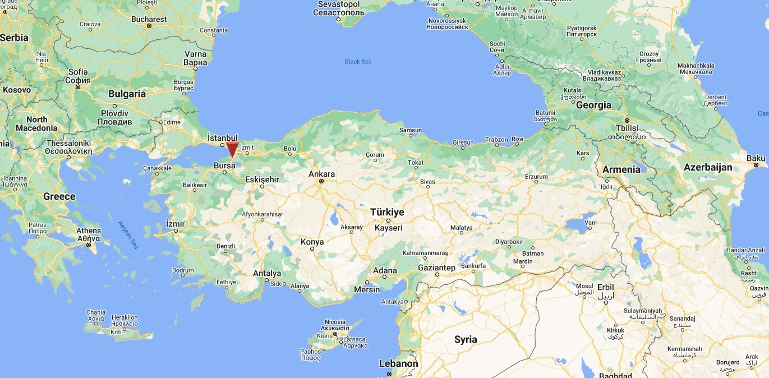

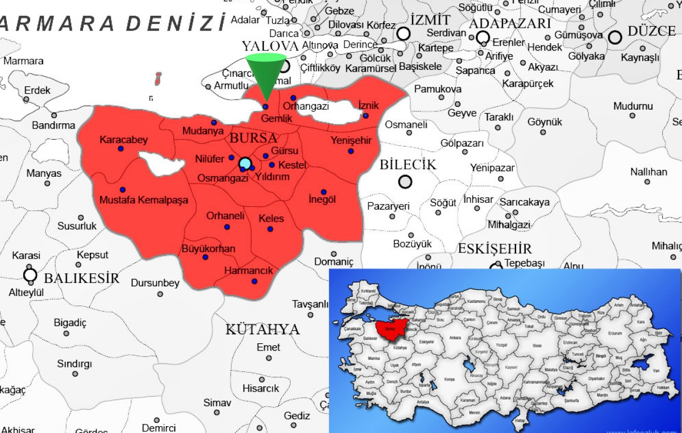

The accommodation of the project is in a hotel named “Atamer Hotel” in village Kumla/district Gemlik / province Bursa. Atamer Hotel is located in Kumla, a small village close to Gemlik (which is 30 km far from Bursa and easily reachable by bus). The hotel is on the seaside of the Marmara Sea. During the period of our project, the owner of the hotel stated that they would gladly host us.
The place has got a large restaurant, a common room with tables for spend the free time and the biggest part of the activity, another smaller activity room and 48 bedrooms (from 3 to 4 persons per room and each one with a private toilet). The hotel has got a free wi-fi connection.

Hotels Pictures…
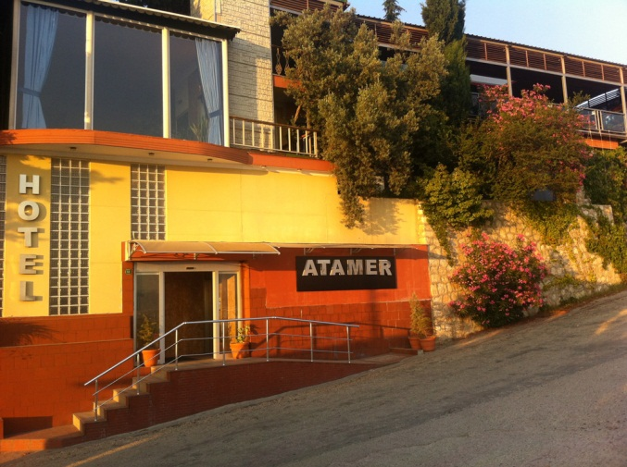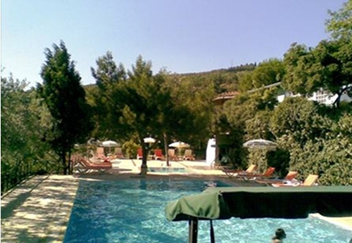

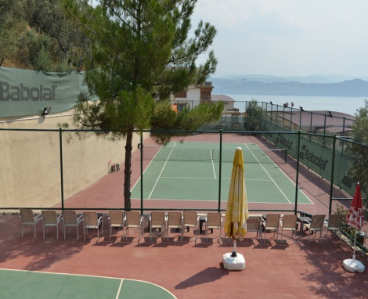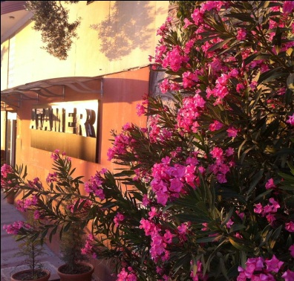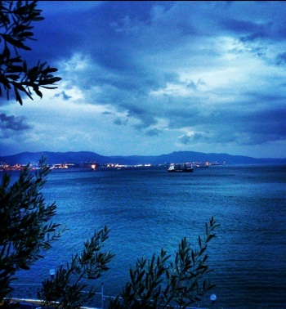

CURRENCY

In Turkey the currency is Turkish Lira.

4. Participants
In the project we plan to realize, all participating groups will make their choices by adhering to the participant criteria. Each group to be included in the activities was determined as 8 participants and 1 group leader. The age range of the participant group was planned as 18-23, and it was requested that an obese participant, which we would describe as disadvantaged, should take place in each participant group. By including obese participants in our project, we aim to raise awareness by including disadvantaged youth in this study. We think that gender differences will be beneficial for inter-communal cultural reflection. In this context, the necessity of ensuring gender equality emerges. Although there is no upper age limit for group leaders, they must have an active and social structure, taking part in activites.

5. Reimbursement
This project will be implemented within the framework of Erasmus + Programme of the European Commission (K1). Hence, all costs related to food, accommodation and activities will be paid in full. The travel costs are financed by European Commission, attending to the programme rules according to distance calculator.

Please see on the link: http://ec.europa.eu/programmes/erasmus-plus/tools/distance_en.htm
 | COUNTRY | KILOMETRES |  | AMOUNT (€) / participant
Serbia |  |  | 500 - 1999 km |  | Until 275,00 €
Italy |  |  | 500 - 1999 km |  | Until 275,00 €
Slovakia |  |  | 500 - 1999 km |  | Until 275,00 €

You will get 100% of your travel expenses reimbursed. We can reimburse only the cheapest transportation possible, so use only public transportation, 2nd class and no taxis.
In order to make the reimbursement, we need:
- An invoice where it's declared the itinerary of your trip, the names of the passengers and, very important, the price of the ticket. For the groups who are gonna book plane tickets, it's enough for us to have the confirmation e-mail that you should get from the flight carrier.

- All your travel tickets (train and bus tickets, boarding passes, etc.). The boarding pass is a very important document, because it's the evidence that you actually travelled, so don't throw it away when you get off the plane, but give it immediately
to your group leader.

The participant organizations and the number of the participants;

GEMLIK HALK EĞİTİM MERKEZI MUDURLUGU, -TURKEY,9 participants,
PROFESSİONALE STATALE SOCİOCOMMERCİALEARTİGİANALE - ITALY, 9 participants, BEOGRADSKA AKADEMİJA POSLOVNİH STUDAİJA – SERBİA, 9 participants,
ADEL – SLOVAKİA, – 9 participants,

The reimbursement will be done after the end of the project, when we'll get back all your tickets and boarding passes from the trip back. All the information about when and where to send the tickets will be given during the project.

IMPORTANT:
All fee of the project will be calculated the last day.

6. Travel Informations

By plane:

İstanbul Sabiha Gokcen is the best airport to fly to. Seeing that you'll need a bit of time for get to Bursa from İstanbul, we'd gently ask you to try to arrive in İstanbul on the arrival day (15th May 2023) not later than 16:00 p.m. For the same reason, on the 25 ^{th} of May, the departure of your plane possibly shouldn't be earlier than 10:00 a.m.

In Bursa we have one airport for internal fly. Usually we are using the İstanbul’s airports for international fly. İstanbul Airport is situated on the European side of İstanbul and its far to Bursa. The nearest airport to Bursa is Airport Sabiha Gökçen situated on the Asian part of İstanbul. Let us know in which one you will fly to and we'll provide to send you a time schedule with all the information about how to reach the meeting point, which is gonna be the bus station to Gemlik / Bursa. In Gemlik station there's no possibility to get lost, the station is pretty small and once you'll get there, we will come to pick you up by car for bring you to the accommodation (the trip lasts around 15 minutes).

IMPORTANT:
Seeing that you'll need to take some transportations for get from the airport to the Bus station of Gemlik (and vice versa on the departure day), we'd suggest you to save some money from your personal budget and to try to not spend them all for the plane ticket.

For any question:

Adnan ULUĞ İhsan KARAMAN
Director of Adult Education Center Gemlik District National
adnanulug@hotmail.com Education Project Coordinator
mobile:+905326613236 ihsan_karaman@hotmail.com
mobile:+905336432169

